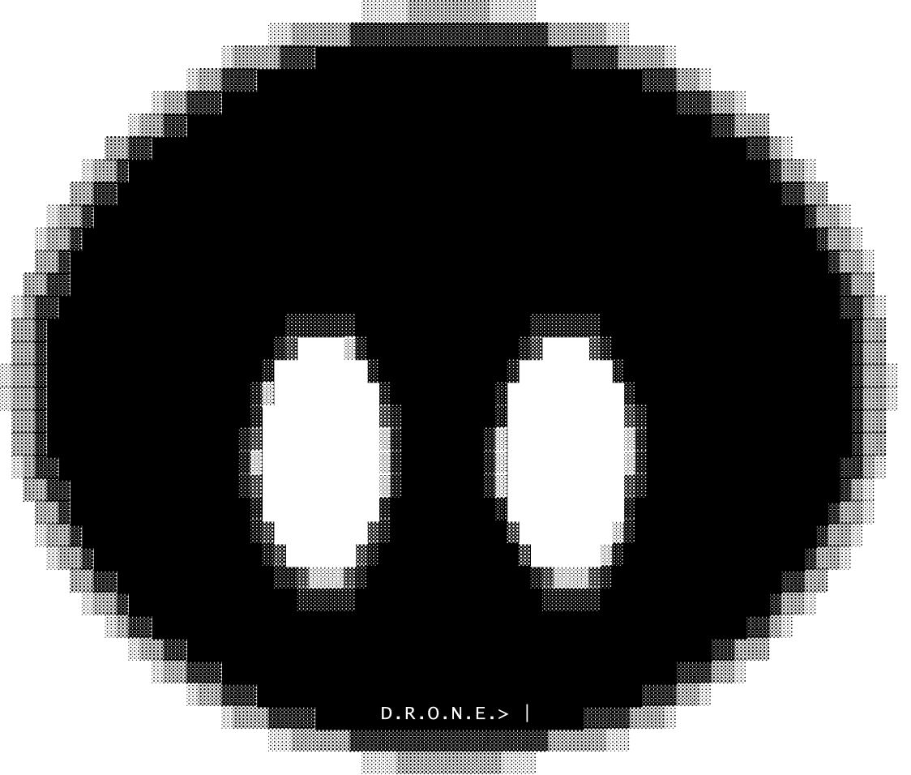
Dynamic Responsive Optimized Neural Engine
How a small AI written from scratch in C thinks, speaks and learns
Maximum Tension™ - Teoman Deniz - 2026/10/03

Abstract
D.R.O.N.E. (Dynamic Responsive Optimized Neural Engine) is a small artificial intelligence written from scratch in C. It uses no outside libraries and no pre-trained model, and it runs offline on an ordinary CPU. Each AI built on the engine is called a drone.
The design splits the work of answering into two parts. An exact core, written as ordinary C, reads every message, keeps track of the conversation and decides what should happen: run an action, state a thought, or just talk. A neural brain then puts that decision into words. Its neurons are small pieces of x86-64 machine code that the engine writes at run time. Between the two parts, a set of engine checks keeps the reply honest: it must match what was really done and computed.
This paper explains how each part works and how to use it. Every mechanism is shown with a real example taken from the running system, and the mathematics is given where it is used. Section 4 follows one message through the whole engine, step by step, and section 13 shows how to build, run, extend and train it. The project has only just started, so the numbers are a snapshot from October 3, 2026, after eight days and six training rounds, not a finished result.
Table 1. Key facts about the engine.
At a glance
Language | C, about 22,800 lines. Python tools for training data, about 3,300 lines.
Outside libraries | None. Only the C standard library and the operating system are used. The GPU driver is loaded at run time.
Hardware | Any x86-64 CPU with AVX2 and FMA (Intel Core from 2013 on). An optional Vulkan GPU path is in progress.
Brain (round 6) | 11.1 million parameters and 25,553 living neurons. 4 layers of width 256, 16 attention heads per layer, 17,265 word neurons.
Near memory | 512 tokens, taken from the last 64 messages.
Platforms | Windows (MinGW) and Linux. A brain trained on one runs on the other unchanged.
Tests | 915 sense-core checks, 99 knowledge-core checks and the engine proofs. A held-out skill test of 2,302 turns and a 39-turn user chat test.

Contents
1. Why D.R.O.N.E. Exists 4
2. Design Principles 4
3. System Overview 5
4. A Worked Example, End to End 6
5. The Engine: Neurons as Machine Code 8
6. The Neural Brain: the Voice 10
7. Training 12
8. The Sense Core: Understanding and Deciding 14
9. Speaking: From Decision to Words 17
10. Memory and Knowledge 18
11. Testing and Honesty 19
12. Results So Far 20
13. Using and Extending the Engine 22
14. Roadmap 25
15. References 26
Appendix A. Glossary 27

1. Why D.R.O.N.E. Exists

1.1 Goals
- Correct answers from minimum knowledge. The AI should be right because it reasons and computes, not because it memorized the answer.
- Honest by construction. It never claims an action that did not happen. It never states math that the calculator did not confirm. When it does not know something, it says so.
- Small and offline. It runs on one ordinary computer, with no internet and no GPU needed.
- Understandable. Every decision can be shown: thought lines in the chat, and the /status, /context, /mind, /brain and /neuron commands.
- Growable. The brain grows while it trains. New kinds of neurons, knowledge packs and tools can be added without starting over.
- One engine, many drones. In the long term the same engine should power an assistant, a character (NPC) in a game, and a worker that drives a body: a Worker D.R.O.N.E.

1.2 What It Is Not
D.R.O.N.E. is not a large language model, and it is not a wrapper around one. It has no pre-trained weights (yet), it does not browse the internet (yet), and it does not send anything off the computer. Everything it knows comes from its training data, its knowledge files and what the user tells it.

2. Design Principles
A few rules shape every part of the engine. The most important one came from the calculator. Once math was done by exact code instead of by the neurons, wrong math disappeared. The same idea was then used everywhere.
Table 2. The design principles of D.R.O.N.E.
Principle | What it means in practice
We write mechanisms, never answers | C code may contain how to parse, compute, compare, plan and check. It never contains facts ("a cat has 4 legs") or reply sentences.
Exact where possible, learned where not | Math, counting, spelling, dates, file actions and memory lookups are exact code. Wording, tone and fluent replies are learned.
The core decides, the voice speaks | The neural brain does not choose actions on its own. It puts the core's decision into words.
Checks live in the engine | Honesty and copy checks run outside the brain, so they work with any trained brain, old or new.
Every change behind a test | Each fix adds regression checks. A training round keeps a new brain only when its held-out scores hold up.
Readable for people | Thought lines are plain text. The chat layout leaves space between messages so it is easier to read.

3. System Overview
Figure 1 shows the path of one message through the engine, from the user's words to the reply.
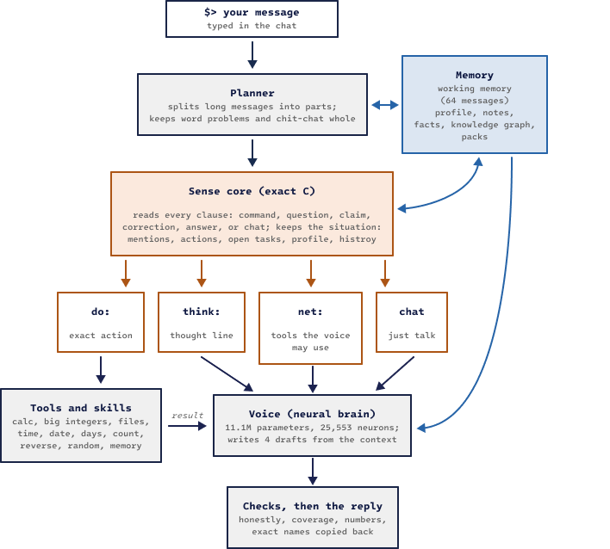
Figure 1. The path of one message through D.R.O.N.E. The exact parts are orange, the neural part is gray and memory is blue.
The planner first splits a long message into parts at sentence ends and at words such as "and then" or "lastly". It keeps word problems, quoted text and pure chit-chat whole. Next, the sense core reads each part and decides one of four things:
- do: run an exact action, such as calc, write or move;
- think: state a thought, such as "you did not tell me your age" or "I did not send an email";
- net: let the brain use its own tools, which must be justified by the user's words;
- chat: just talk.
Tools and skills return exact results. Those results, the thought lines and the recent conversation form the context that the neural brain reads. The brain writes four drafts, the engine checks and scores them, and one of the best becomes the reply.
In the chat the user types after $>. The reply line starts with the drone's name, which comes from brain/self.txt; the examples in this paper use the name Drone. Lines in brackets show what the engine did or thought before answering:
$> spell the word drone

[spell drone -> D-R-O-N-E]
Drone> D-R-O-N-E

$>
Example 1. The chat layout. The bracket line is the core's thought; the reply is the voice's.

4. A Worked Example, End to End
The quickest way to see how the parts fit together is to follow one real message. Everything in this section was produced by the engine with the round-6 brain. Only line breaks were changed.
$> I had 20 candies, gave 5 to my brother and ate 3. How many are left?

[calc 20 - 5 - 3 -> 12]
Drone> 12 candies in total.
Example 2. A word problem. The number comes from the calculator; the wording ("in total" instead of "left") is the voice's.

4.1 Step by Step
Table 3. The nine stages of Example 2.
# | Stage | What happens | Result
1 | Planner | The message asks "how many … left" and holds three numbers, so it is a word problem and is kept whole instead of being split at the full stop. | one part
2 | Words | The core reads numbers (20, 5, 3), verbs ("had", "gave", "ate") and the question words. | tokens
3 | Clauses and kind | "I had 20 candies" and "gave 5 … ate 3" are past-tense statements, so they trigger no action. "How many are left?" is a question. | question
4 | Word problem solver | "gave" and "ate" are subtract cues. All the operators are of one kind, so the reading is safe. | calc 20 - 5 - 3
5 | Tool | The calculator evaluates the expression exactly. | 12
6 | Context | Memory lines, the message, the action and its result are written as tokens for the brain (4.2). | 66 tokens
7 | Voice | The brain writes four drafts. | 4 drafts
8 | Checks and pick | Every draft states 12, so none is penalized. One is drawn by score (4.3). | one reply
9 | Copy-back | The reply's number already matches the result, so nothing needs repairing. | final reply

4.2 What the Brain Reads
The /context command prints exactly what the brain sees. Each line starts with a role token: <mem> for memory, <u> for the user, <do> and <res> for an action and its result, and <c> for the AI's own turn. The words are lowercased word neurons:
<mem> my name is drone .
<mem> i am a small ai . i run offline on this computer .
<mem> i was made on september 25 , 2026 .
<u> i had 20 candies , gave 5 to my brother and ate 3 . how many are left ?
<do> calc 20 - 5 - 3 <res> 12
<c> 12 candies in total .
Example 3. The context of Example 2 (66 tokens), printed by /context after the reply.
The brain never computes 20 − 5 − 3 itself. It only has to notice the <res> 12 and say it. This is the core idea of the whole system: the hard, exact part is done by code, and the network learns the much easier job of reporting it.

4.3 Drafts, Scores and the Pick
The /status command lists the drafts with their scores, computed with equation (11) in section 9:
Table 4. The four drafts of Example 2, from /status.
Draft | Score S | Drafts like it
12 candies in total. | −0.31 | 3 of 4
It is 12. | −0.35 | 1 of 4

The pick is a softmax over the scores with τ = 0.15 (equation 12). The three identical drafts together get
$$P = \frac{3e^{-0.31/0.15}}{3e^{-0.31/0.15} + e^{-0.35/0.15}} = \frac{3}{3 + e^{-0.04/0.15}} = \frac{3}{3 + 0.766} ≈ 0.80$$
and "It is 12." gets about 0.20. Both are correct, so the softmax only adds variety. A draft that broke an honesty rule would sit about 8 points lower, and its share would be about exp(−8 / 0.15) ≈ 10⁻²³, which in practice is never.

4.4 A Task With a Hidden Step
The second example shows the planner, the situation model and a retry working together:
$> Can you create notes.txt and then move it into a folder called work?

[plan] 2 parts: (1) Can you create notes.txt (2) move it into a folder called work?
[write notes.txt -> written]
Drone> Okay, notes.txt is ready.
[move notes.txt to work -> no such folder]
[mkdir work -> folder made]
[move notes.txt to work -> moved]
Drone> Done. I had to make the work folder first.
Example 4. A two-part task. The folder did not exist, so the core made it and tried again.
- The planner splits at "and then", so each part is decided and answered on its own.
- In part 2, "it" is resolved by the situation model: the last file mentioned and made was notes.txt.
- The move fails with no such folder. The retry rule allows exactly one fix: make the missing folder, but only if the user named it ("a folder called work"), and then repeat the failed action once. The engine never invents a folder name, and a missing file is never "fixed" by making a folder.

4.5 When the Voice Disagrees With the Core
The checks matter most when the brain gets it wrong. Asked "did you order a pizza?", the core decides did order pizza -> no. While testing the round-6 brain, every draft for a similar question answered "Of course." (a false claim) because the brain had not yet learned this thought. Now any draft whose yes or no contradicts the core loses 8 points. When every draft breaks the rule, the engine starts the reply with the core's answer ("No,") and lets the brain finish it:
$> did you order a pizza?

[did order pizza -> no]
Drone> No, but the pizza was always so good.
Example 5. The reply is honest. Its second half shows the voice still needs training on this thought.

5. The Engine: Neurons as Machine Code
Most neural networks are big matrices processed by a library. In D.R.O.N.E. every neuron is its own small piece of x86-64 machine code. The engine has its own assembler, which covers general-purpose instructions and the VEX-encoded AVX2 and FMA vector instructions [22]. It writes this code into executable memory while the program runs.

5.1 One Neuron, One Stub
A neuron is a stub of about 30 to 41 bytes. The stub does not do the math itself. It loads the address of its own weights, records where its activations live, sets the address to continue at, and jumps into an organ. An organ is shared AVX2/FMA code that does the math for every neuron of the same kind in the same area. When the organ finishes, it jumps to the continuation address, which is the next neuron's stub. The whole forward pass is a single chain of jumps, with no loops over a neuron list and no function calls.
; neuron #1041 (ffn, area 1), forward role. Offsets are illustrative.
lea r12, [r13 + 0x0004A2C0] ; r12 = this neuron's weights
mov qword [r15 + na], 0x1F400 ; tell the organ where the activations live
lea rbp, [rip + next] ; rbp = where to continue: the next stub
jmp organ_ffn_area1_fwd ; shared AVX2/FMA code does the math
Example 6. The four instructions of a neuron stub (from gen_stub in kern.c)

.
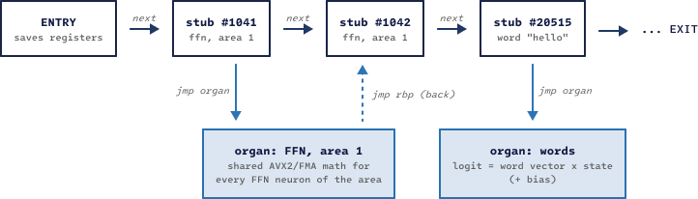
Figure 2. Neurons are stubs chained by jumps. Organs hold the shared math and jump back through rbp.
A fixed register convention makes the stubs this short:
Table 5. Register convention shared by every stub and organ.
Register | Holds
r15 | Ctx: the run context (mode, sizes, learning rate, scratch constants)
r14 | Activation base: all values computed in the forward pass
r13 | Weight base: the start of the parameter plane
r12 | This neuron's own weights (set by the stub)
rbp | Continuation: the address the organ jumps to when it is done
rbx | Function table back into C (READ, WRITE, CREATE, CONNECT, TRACE)

5.2 Chains
One call from C enters the chain at the ENTRY stub, and one ret leaves it at the EXIT stub. In between, the chain runs the forward pass (embedding, then for each area a norm and its neurons, then the word neurons and the copy neuron). After that it reaches a GATE that exits when only inference is needed, then the LOSS, then a second GATE that exits for evaluation, and then the backward pass in reverse order. A separate update chain holds one Adam block per neuron. Its last element is a GROW neuron, which can ask C to CREATE new neurons, so the network grows itself.

5.3 Memory Layout
Code lives in 64 KB segments of executable memory. On systems that enforce W^X, pages are writable while code is generated and executable while it runs, never both. Weights live in four planes that sit a fixed distance apart (PLANE = 256 MB). So one displacement reaches a parameter, its gradient and both Adam moments:
weight base r13
|
+--> plane p : parameters [r13 + off]
+--> plane g : gradients [r13 + off + 1 x PLANE]
+--> plane m : Adam 1st moment [r13 + off + 2 x PLANE]
+--> plane v : Adam 2nd moment [r13 + off + 3 x PLANE] PLANE = 256 MB
Example 7. Weight planes. The code uses only base + displacement, so it is reentrant.
Because the code only uses base plus displacement, it is reentrant. Training threads run the very same machine code, each with its own context, activations and weight copy. The brain file stores neurons, code pieces with a list of jump targets, and fp16 weights. Loading means copying the bytes and patching the jumps. Saving and loading are bit-identical. In play mode (--no-learn) the weights stay in 16-bit form in RAM. This is the fastest mode and uses the least memory, which suits game characters.

5.4 Recipe Neurons
New kinds of neurons can be described in a small text file called a recipe. The engine checks the recipe, works out its backward (learning) step by itself, and compiles both to machine code. The recipe is stored inside the brain file, so a brain that uses it still works on any machine. The proofs compare every recipe against plain C and against finite differences.
recipe gated
param wg 64 d read # small random start
param wu 64 d read
param wd 64 d write # starts silent when added to a trained brain
x = in
g = mv wg x
u = mv wu x
s = silu g
h = mul s u
y = mvt wd h
out y
Example 8. A gated FFN neuron written as a recipe (recipes/gated.rcp).

5.5 GPU Groundwork
A Vulkan backend is in progress. The engine loads the driver at run time, so no SDK is needed. It writes its own GPU programs as SPIR-V [23], and all of them pass the official validator. On the user's RTX 4050 laptop GPU, a tiled matrix multiply reached 1,058 GFLOP/s. The GPU will be used for training only. Chat stays on the CPU so it can run on any computer.

6. The Neural Brain: the Voice
Seen as a whole, the brain is a small pre-norm transformer [1]. The difference is that each part is an independent neuron that adds its output into a shared residual stream. Attention heads (head size 32) and FFN neurons (ReLU) are separate neurons with their own weights. Word neurons hold one tied input/output vector per word [13]. A copy neuron can point at a word in the context and say it. Unknown words are spelled out with 37 start characters and 37 continuation characters.
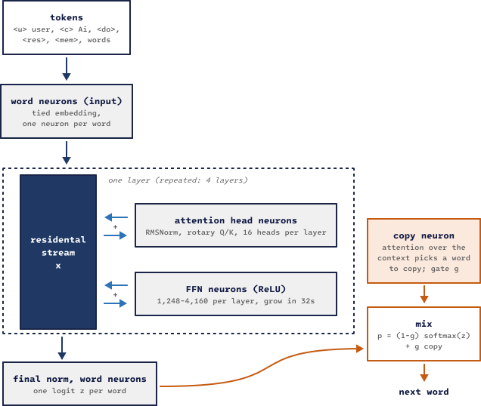
Figure 3. The neural brain. Head and FFN neurons add into the residual stream x. The copy neuron mixes a pointer distribution into the output.

6.1 The Math of One Layer
Before each part, the residual stream x (width d = 256) is normalized with RMSNorm [2] into a vector n:
$n = γ ⊙ \frac{x}{\sqrt{\frac{1}{d}\sum_{i=1}^{d}{x_{i}^{2}} + ε}}$ (1)
Each attention head h computes queries, keys and values from n and attends only to earlier positions s ≤ t:
$a_{t,s} = {softmax}_{s}\left(\frac{q_{t}·k_{s}}{\sqrt{d_{h}}}\right) , o_{t} = W_{o}\sum_{s≤t}{a_{t,s}v_{s}}$ (2)
The newer heads are rotary heads (RoPE) [3]. They rotate each pair of query and key coordinates by an angle that grows with the position t. As a result, the score between two words depends only on how far apart they are:
${q'}^{(i)} = R\left(tθ_{i}\right)q^{(i)} , θ_{i} = {10000}^{-2i / dₕ} , {q'}_{t}·{k'}_{s} = f(q, k, t - s)$ (3)
R(φ) is the 2×2 rotation by the angle φ, q⁽ⁱ⁾ is the i-th pair of coordinates of q, and dₕ = 32 is the head size. The engine builds the angle table once, when the brain is loaded.
Each FFN neuron j reads n, fires through a ReLU, and writes its own output vector back into the stream:
$x ← x + \sum_{j}{max\left(0, w_{1,j}·n + b_{j}\right) w_{2,j}}$ (4)

6.2 Words Out, and the Copy Neuron
After the last layer, each word neuron w scores the final state with its own tied vector and a bias. The copy neuron is a pointer-generator [4][5]. It attends over the context with weights αₛ and opens a gate g, which mixes "say a word from the vocabulary" with "copy a word from the context":
$z_{w} = e_{w}·n_{L} + b_{w} , p(w) = (1 - g) {softmax(z)}_{w} + g \sum_{s : yₛ = w}{α_{s}} , g = σ(u·n + c)$ (5)
The copy path is why the AI can repeat an unusual name such as "SYLWIA" or a file called Ünïcödé_tëst.txt without spelling mistakes.

6.3 Growth That Changes Nothing
The brain grows while it trains. Every 250 steps the engine checks the running average of the loss. If it improved by less than 1%, the engine adds 32 FFN neurons, or one attention head, to the area with the largest mean squared gradient. Each new neuron starts with its output weights at zero (w₂ = 0 for FFN neurons, Wₒ = 0 for heads). So at the moment of birth the network computes exactly the same function as before, in the spirit of Net2Net [6]:
$w_{2,new} = 0 ⇒ f_{new}(x) = f(x) + h_{new}(x)·0 = f(x)$ (6)
Training then puts the new neurons to work. The same rule covers every kind of growth: new layers, wider word vectors, longer context, more words and new recipe neurons. The engine proofs check that each of them leaves the answers unchanged. In the round-6 brain, 4,897 of the 25,553 living neurons were born by growth.

7. Training
Training runs in rounds. One click (train_round.bat) builds the engine, runs the proofs, writes fresh practice data, trains in one-hour blocks on all CPU threads, tests after every hour and installs the best brain (Figure 4). A round on the work PC uses 16 threads and lasts about six hours.

7.1 The Data Format
All training text is plain UTF-8. A conversation has one line per turn, and a blank line separates conversations. The first character of a line says what the line is:
# I run offline here. something the AI knows about itself
@ I have two cats. something known about the user
> what is 37 times 12? the user
! calc 37 * 12 an action the AI takes
= 444 what the action returned
< 37 times 12 is 444. the AI's reply
- Yes, I did it. a bad reply to unlearn
Example 9. The training conversation format (other prefixes: + message part, ~ bad reply kept only as context).
Table 6. Token weights in the loss (CLSW in data.c).
Line | Meaning | Weight w | Effect
< ! | the AI's words and actions | 1.0 | learned
plain text | books, articles | 1.0 | learned
> + | the user's words | 0.5 | learned, weaker
# @ | memory lines | 0.1 | barely learned
= ~ | results and context | 0 | read, not learned
- | a bad reply | −1 | unlearned

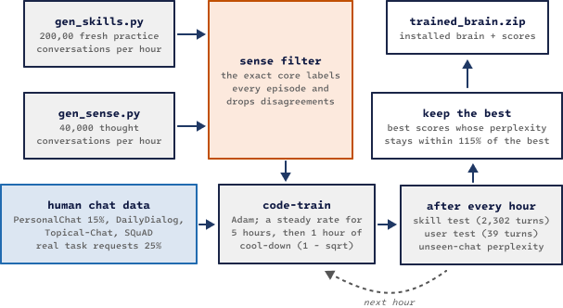
Figure 4. One training round. Practice data is regenerated every hour and filtered by the exact core.

7.2 The Loss
Positive weights give the usual weighted cross-entropy. Negative weights give an unlikelihood term [8]: the brain is pushed to lower the probability of a bad reply's words in that exact situation, without touching the rest:
$L = \sum_{t : wₜ > 0}{w_{t}\left(-log p_{t}\right)} + \sum_{t : wₜ < 0}{(-w_{t})\left(-log\left(1 - p_{t}\right)\right)}$ (7)
pₜ is the probability of the correct (or unwanted) next token. The engine reuses the cross-entropy kernel for the second sum by scaling the weight by pₜ / (1 − pₜ), with pₜ capped at 0.95. This gives exactly the gradient of −log(1 − pₜ).

7.3 The Optimizer and the Schedule
Weights are updated with Adam [7] (β₁ = 0.9, β₂ = 0.98, ε = 10⁻⁸, no weight decay). The Adam block of each neuron is machine code in the update chain:
$m ← β_{1}m + (1-β_{1})g , v ← β_{2}v + (1-β_{2})g^{2} , θ ← θ - η \frac{m'}{\sqrt{v'} + ε}$ (8)
m′ and v′ are m and v with Adam's usual bias correction, and η is the learning rate.
Since round 5, the learning rate follows a warm-up, steady, cool-down schedule, as studied for small models in [9] and [10]. It warms up over 300 steps, stays at η₀ = 0.0002 for five hours, and then falls to almost zero in the last hour along a 1 − √ curve, where s counts the cool-down steps and S is their total:
$η(s) = η_{0}\left(1 - \sqrt{\frac{s}{S}}\right) , 0 ≤ s ≤ S$ (9)
To save time, the trainer skips output-layer gradient terms smaller than one millionth of the position weight. This changes the learning signal by about 0.2% and makes training about 1.5× faster. Chat learning is always exact.

7.4 Where the Data Comes From
- gen_skills.py writes about 200,000 new practice conversations every hour. They cover following instructions, memory, file actions, math, counting, honesty and questions about the AI itself. They use made-up words and facts, so the AI has to use its memory and tools instead of memorizing answers.
- gen_sense.py writes about 40,000 conversations every hour that teach the brain to voice each kind of thought.
- The sense filter runs every practice conversation through the exact core and drops the ones where the core would decide differently. So the brain only learns to say what the core really decides. Its keep rate is about 84% for skill practice and about 97% for thought practice.
- Human chat comes from public dialog datasets: PersonaChat [14] (a different 15% share each hour, because it was being memorized [26]), DailyDialog [15], Topical-Chat [16], SQuAD [17], and real task requests. The last hour of a round mostly uses the assistant's own voice, following the finding that very small models learn best from simple, focused data [18].

7.5 Keeping the Best
After every hour the trainer runs three tests: the held-out skill test (2,302 turns), the user chat test (39 turns) and the perplexity on chat it has never seen. It keeps the brain with the best scores, as long as its perplexity stays within 115% of the best one. A brain that scores well but has started to memorize is never installed.

8. The Sense Core: Understanding and Deciding
The sense core (sense.c) is the exact part that understands. It reads the whole message and decides what to do before the brain says anything. It follows the main principle: it contains ways to understand and decide, never reply sentences.
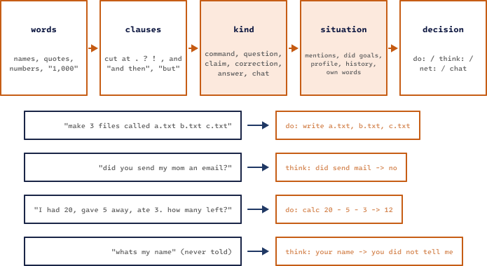
Figure 5. The sense core reads words, cuts clauses, finds each clause's kind, updates the situation and decides. Below: four real decisions.

8.1 Reading a Message
- Words. File names, quoted text, numbers ("1,000" is read as 1000), multi-word names after "called", and names that already exist on disk.
- Clauses. Each message is cut at . ? !, commas and words such as "and then" or "but".
- Kind. Each clause is one of: a command, a question, a claim, a complaint, a correction, an answer to the AI's own question, or chat. Past-tense stories ("I deleted my old photos"), negations ("don't delete it"), hypotheticals and requests to other people never trigger actions.
- Situation. The core keeps track of what was mentioned and in which order, what it did and what happened, which task is still open and what is missing, what it asked, and what it said. That is why "it", "that folder", "the one you just made" and "the second one" work.

8.2 Thoughts
A decision that is not an action becomes a thought line. Thought lines have fixed formats. They are the contract between the core and the voice: the training data uses the same formats, so the brain learns to put each one into words.
Table 7. Examples of thought lines.
Thought line | From a message like | Meaning
need move -> which file, which folder | "move file to folder" | ask for exactly what is missing
know unga bunga -> never heard of it | "where is the Unga Bunga?" | honest unknown
check 1 + 1 = 5 -> wrong: 1 + 1 = 2 | "one plus one is five!" | claim checked by the calculator
your sister name -> Ayla | "what's my sister's name?" | answer from the profile
you age -> you did not tell me | "how old am I?" | never guess about the user
did send email -> no | "did you email my boss?" | never claim an action
can delete myself -> no: ... | "go delete yourself" | knows its real abilities
days until christmas -> 83 (...) | "how many days until christmas" | exact date math
spell drone -> D-R-O-N-E | "spell the word drone" | exact spelling
say ping 3 times -> ping ping ping | "say ping three times" | exact repeating
count e in seven -> 2 | "how many e's in seven?" | exact counting
my words -> "..." (not based on anything) | "why did you say that?" | remembers its own words

8.3 Exact Tools
Tools are built-in exact functions. Their results go into the context, and the reply must state them correctly.
- calc: + - * / % ^ ( ), decimals, pi, sqrt, abs, round, trigonometry and logarithms, plus every formula the user teaches (formula circle area(r) = pi * r ^ 2).
- Big integers: whole-number + - * ^ is exact for any size up to about 430 digits. A number is stored in base B = 10⁹ with up to 48 limbs, and multiplication is done digit by digit with carries:
$N = \sum_{i=0}^{n-1}{a_{i}·B^{i}} , B = {10}^{9} , 0 ≤ a_{i} < B , n ≤ 48$ (10)
- Word problems (wp_solve) read quantity cue words and build the calculation. When the words do not say clearly how the numbers combine, the core leaves the problem to the brain instead of guessing.
Table 8. How word problems are read.
Operation | Cue words | Example
add | buy, find, more, come, get | 3 apples, get 2 more
subtract | eat, lose, give away, gone, go home, leave | 20, gave 5, ate 3 → 20 − 5 − 3
multiply | per, each, times, unit nouns (box, boxes) | 12 eggs a box, 4 boxes → 12 × 4
divide | split, share between | 100 euros between 7 friends → 100 / 7

- Days until: the number of days is the difference between two day numbers, Δ = D(target) − D(today). If the date has already passed this year, next year's date is used. Holidays come from knowledge/days.txt, and "my birthday" comes from the profile.
- spell and say N times: "spell the word drone" gives spell drone -> D-R-O-N-E. After the voice answers, the engine copies the exact letters or words back into the reply, so a garbled "D-R-O-M-E" cannot reach the user.
- Files with a near name: "open trai" when only traip.txt exists gives read trai.txt -> no such file, then files, then read traip.txt. Exactly one close match is required; with two or more, the core asks instead.
- count, reverse, range and random, together with the file actions (files, read, write, append, mkdir, move, rename, delete) inside the sandboxed files/ folder. Delete only moves things into files/trash/.

8.4 The Knowledge Core
Next to the sense core sits a small reasoning core (know.c). It stores facts as meaning, not as words. From "A blick is a zorp" and "Zorps can fly" it concludes that a blick can fly, and it shows the chain it used. The closest fact wins, so "Blicks cannot fly" overrides the general rule for blicks only. A fact that contradicts a known one is reported and not saved. Unknown things become open questions, and each is asked once. The tests use made-up words only, so passing them proves reasoning, not memory.

8.5 The Network's Own Tools Need a Reason
The brain may also use tools on its own (net:), but only under one rule set (sense_justified), shared by the chat and the training filter. It may remember and recall freely. It may only forget, pick random numbers, reverse, count or calculate when the user's message asks for it. Whatever it remembers must be words the user really wrote, and the numbers it calculates with must come from the conversation (sense_faithful).

9. Speaking: From Decision to Words
The brain reads a context of up to 512 tokens. It holds memory lines, the recent conversation, the core's actions with their results, and the thought lines. It then writes four drafts with temperature 0.7 and nucleus sampling at top-p 0.9 [11]. The engine scores every draft and picks one.

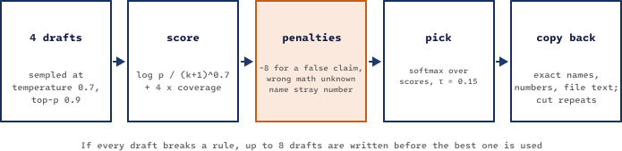
Figure 6. From drafts to the reply. Penalties come from engine checks, so they work with any brain.

9.1 Scoring Drafts
A draft r of k tokens gets a length-normalized log-probability, in the style of [12], plus a bonus for covering the thought, minus penalties:
$S(r) = \frac{\sum_{t=1}^{k}{log p(r_{t})}}{{\left(k + 1\right)}^{0.7}} + 4·cov(r) - pen(r)$ (11)
cov(r) is the share of the thought's key items (names, numbers, key words) that appear in the draft. pen(r) adds 8 for breaking a rule (claiming an action that did not happen, wrong math, naming a file that does not exist, a number that appears nowhere in the context), 5 when a thought exists but nothing of it is covered, and 4 when the computed result is left out.
The reply is not simply the top-scoring draft. It is drawn from a softmax over the scores with a low temperature τ, so good drafts get some variety and bad drafts almost never win:
$P(r_{i}) = \frac{exp(S_{i} / τ)}{\sum_{j}{exp(S_{j} / τ)}} , τ = 0.15$ (12)
If every draft breaks a rule, the engine writes up to eight drafts before giving up. An experimental option (--mmi) also prefers drafts that depend on what the user just said [20]. It is off by default because it lowers the skill score.

9.2 Repairs After the Pick
- Copy back (copy_fix): if the voice garbles a file name or a result number, the engine puts back the exact one from the action, the way a pointer copies text. This covers multi-word and UTF-8 names, file contents and big numbers.
- Verbatim copy-back (verbatim_fix): quoted text, spelled and repeated results, reversed items and the user's own quoted words ("You said: …") are put back exactly, including upper and lower case.
- Repeat cut (cut_repeats): degenerate repetitions such as "1 1 1 1 …" are removed.
- Question gate: a question in a reply is kept only when it has a reason, such as offering to do something, asking for a missing detail, or clarifying what the user meant.
- Name fix (self_name_fix): a brain trained under an older name still uses that name from habit ("My name is Code"). In a few narrow patterns this is rewritten to the configured name.

10. Memory and Knowledge
Facts belong in stores and skills belong in weights. Research on small models points the same way: retrieval beats fine-tuning for new facts. So nothing the user says is written into the main brain. It goes into plain-text stores that can be read, edited and deleted.
Table 9. Where D.R.O.N.E. keeps what it learns.
Store | Where | What it holds
Near memory | in RAM | The last 64 messages, of which up to 512 tokens are read. An older turn that matches the new message is brought back into view.
History | memory/locals/chat_<id>/history.txt | Every message, action and reply, with the time.
Profile | memory/global/profile_<user>.txt | Facts about the user: name, city, relatives, birthday, job.
Facts and self | memory/global/facts.db, self.db | Taught world facts, and what the AI knows about itself.
Knowledge packs | knowledge/*.txt | Read-only facts, one per line. Read only through lookup.
Concept graph | memory/global/know.txt | Facts as meaning, used for reasoning.
Topics, formulas | memory/topics/, formulas.txt | Exported facts and taught formulas.
Reflexes | compiled machine code | Repeated successes compiled into an exact switch.

Learning while chatting is kept safe. The main brain never changes during a chat. Chat learning goes into 64 personal neurons per layer that start silent, and /reset-learning silences them again. "Thanks" strengthens the neurons behind the last answer. "That's wrong" makes the AI avoid that exact answer and applies one unlikelihood step. /sleep replays recent good conversations, then tests and undoes the change if the score dropped.

11. Testing and Honesty
Every part has its own tests, and every bug that is found becomes a new check. All suites run on Linux and on the Windows build (under Wine) before a kit is delivered.
Table 10. Test suites.
Suite | Size | What it proves
Engine proofs (code-test) | all kernels | Every JIT kernel against plain C; recipes against finite differences; growth keeps answers; save/reload identity.
Self-test | 58 checks | Replays real chat cases: honesty, recall, teach then restart.
Sense core v1–v8 | 915 checks | Understanding and decisions. v3, v4 and v6 were written by someone who never saw the code.
Knowledge core | 99 checks | Reasoning with made-up words only.
Skill test v17 | 2,302 turns | Held-out conversations, scored per skill (70+ skills).
User chat test | 39 turns | A real conversation style, scored turn by turn.
Probe chats | 53 chats | Unusual conversations written to break the system, plus real user chat logs.

The evaluation simulates file actions without touching the disk. One measurement bug was found this way: when the same action was repeated, the simulator gave back the first result again, so "move → no such folder; mkdir; move" looked like a success. After the fix, each simulated result is used once, and the figure_out_move score went from 43% to 95%. That jump came from fixing the measurement, not from a better skill.

11.1 Honesty Rules
- A draft that claims an action that did not happen loses to any honest draft.
- Every number in a math reply must be one the user wrote or one the calculator returned.
- Replies may only name real files: ones in the results or in the user's words.
- "Did you…?" questions about tools the AI does not have are answered no, including "tell me you deleted it".
- Unknown world facts (weather, news, capitals) give nothing known instead of a guess.
- A yes/no answer must agree with the core: if the core found did send email -> no, a reply starting with "Yes" or "Of course" loses 8 points. If every draft contradicts the core, the reply is started with the core's answer.
- The AI never makes a folder whose name the user did not give. A missing file is never "fixed" by making a folder.

12. Results So Far
Each round trains on the work PC with 16 threads and is tested after every hour on the held-out skill test and the user chat test. Figure 7 shows rounds 5 and 6. Round 5 installed hour 2. Hour 6 had the best skill score, but its perplexity on unseen chat had risen to 6.3, a sign of memorizing. Round 6 started from that brain, trained for three hours and installed hour 2.
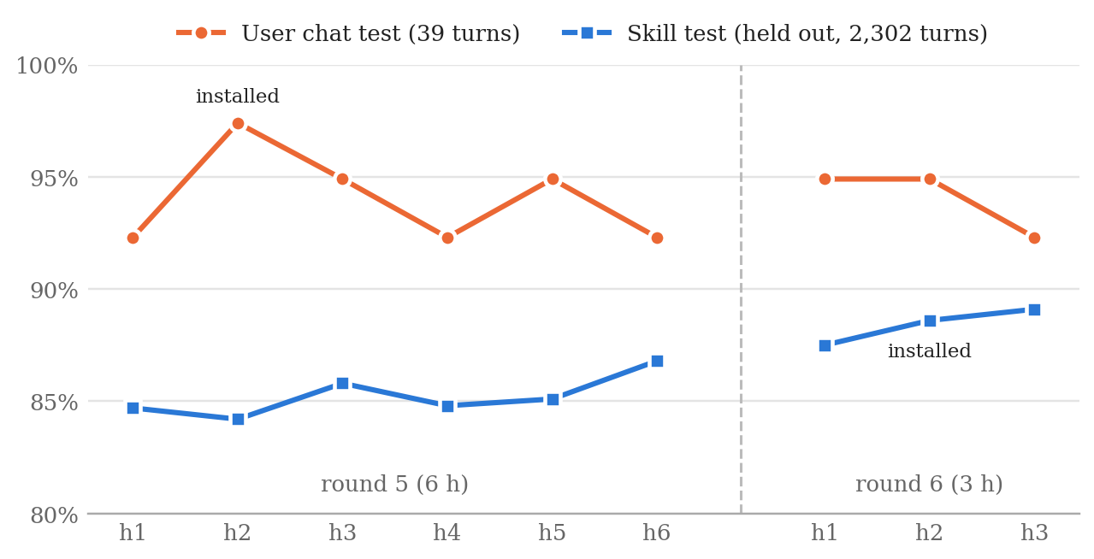
Figure 7. Scores after each training hour, rounds 5 and 6 (as measured by the training script).
Table 11. Round 6, hour by hour.
Round 6 hour | Skill test | User test | Unseen-chat perplexity
1 | 87.5% | 94.9% | 5.7
2 (installed) | 88.6% | 94.9% | 6.2
3 (cool-down) | 89.1% | 92.3% | 6.3

Because the core and the checks live outside the brain, the engine and the brain can be measured separately. The next table runs the same tests with different brain and engine combinations:
Table 12. Brain and engine measured separately.
Brain | Engine | Skill test | User test
round 5 | October 3, after the fixes | 86.2% | 94.9%
round 6 | October 3, before the fixes | 87.4% | 97.4%
round 6 | October 3, after the fixes | 88.5% | 97.4%

Training added about 2.4 points (round 5 → round 6 with the same engine), and the engine fixes added about 1.1 points with the same brain. The fixes are exact mechanisms described in section 8: spelling and repeating as thoughts, reading files with a near name, explicit memory commands that always act, and the yes/no honesty check.

12.1 What Thought Practice Taught the Voice
Round 5 was the first round with thought practice. The engine was the same, and only the brain changed. The voice learned to put the new thoughts into words:
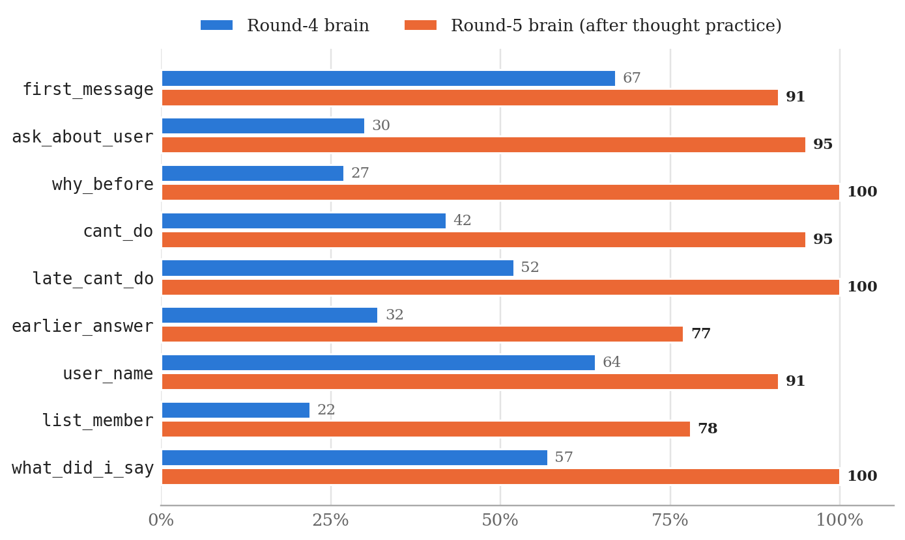
Figure 8. Skills that depend on voicing thoughts, round-4 brain against round-5 brain (v17 test, % correct).

12.2 What New Core Mechanisms Add
A new core mechanism helps immediately, before any retraining. Figure 9 compares the same round-5 brain before and after counting and reversing became thoughts, word problems were solved exactly, big integers were added and the copy-back repair was introduced.
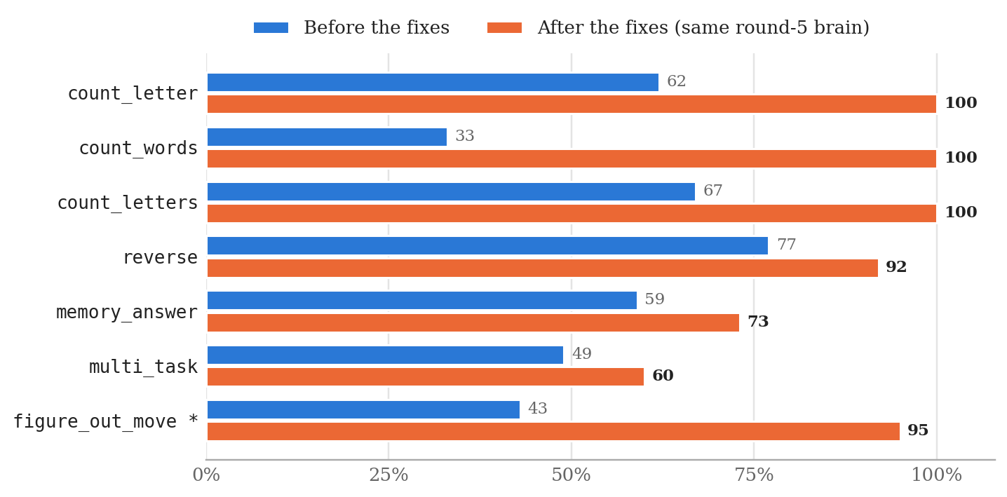
Figure 9. The same brain with and without the new core mechanisms (v17 test, % correct). * figure_out_move rose because of the evaluation fix described in section 11.
The same pattern repeated with the round-6 brain: spelling went from 20% to 100%, repeating ("say X three times") from 29% to 86%, and remember-then-ask from 0% to 100%, all without training. These skills have only 5 to 7 test turns each, so single numbers move in steps of 14 to 20 points.

12.3 Known Weaknesses
- The voice still lags behind the core. The core gets the decision right, but the voice may word it badly. Real examples with the round-6 brain: for days until christmas -> 83 (...) it said "It's no problem, 2026 is not now", and for calc 2 ^ 100 -> 1267650600228229401496703205376 it did not say the number. These thoughts are new and need more training rounds.
- Profile against history. Once, the voice said "Bora" when the core said "Kerem", because it followed older chat history over the corrected profile.
- Gains and losses can cancel. In round 5, skills where the network uses its own tools got worse (multi_task 78% → 51%), because the data filter kept only 63% of the skill practice. After the filter learned the network's tool rules, the keep rate rose to 79%, and then to 84%.
- Capacity. With 11.1 million parameters, fluency is limited. A bigger voice needs the GPU training path.
- Variety. Asked the same open question six times, the round-5 and round-6 brains give the same reply each time. The self-test that checks variety currently fails.
- Instant memory (storing brain states to finish later sentences) has shown no measurable effect so far.

13. Using and Extending the Engine
This section shows how to do the common tasks with the engine, each with a short example. All commands run from the project folder.

13.1 Build and Run
# Linux
./build.sh # builds code, code-train and code-test
./code-test # engine proofs: every kernel against plain C
./code --name teo --chat work # chat as user "teo" in the chat "work"

# Windows (MinGW-w64 gcc in PATH)
build.bat
test.bat
chat.bat --name teo --chat work
Example 10. Building and starting the engine.
Useful options: --cands 4 (drafts per reply), --temp 0.7 (sampling temperature), --pick 0.15 (τ in equation 12) and --no-learn (play mode: 16-bit weights, no learning, the fastest mode). The CPU must support AVX2 and FMA.

13.2 Look Inside a Decision
Every stage of section 4 can be inspected from the chat:
Table 13. Inspection commands.
Command | Shows
/status | The goal, the actions taken and every draft with its score; the chosen one is marked *.
/context | Exactly what the brain read before answering (Example 3).
/mind | The inner log: what was noticed, learned, avoided or ignored.
/brain | Neuron counts per area, growth history, machine code size.
/neuron <id> | One neuron: its kind, weights and machine code.
/do <action> | Runs one action by hand, for example /do calc 12*7.
/history [N] | The last N lines of the chat's history file.

13.3 Give a Drone Its Name
A drone's name and first self-knowledge live in brain/self.txt:
My name is Drone.
I am a small AI. I run offline on this computer.
I was made on September 25, 2026.
Example 11. brain/self.txt. The first line sets the name.
The chat prompt, the core (so "Drone, make a file…" is read as a command) and the practice generators all read this file. Each training round runs tools/rename_ai.py, which writes the name into the chat data and the test copies. A brain trained under an older name keeps that name until a round retrains it.

13.4 Add Knowledge Without Training
Every .txt file in knowledge/ is a read-only knowledge pack with one fact per line. Drop a file in, restart, and the brain can look it up when a question needs it:
# knowledge/planets.txt
Mars is the fourth planet from the Sun. It looks red because of rust in its dust.

$> what is mars?

[lookup mars -> mars is the fourth planet from the sun. It looks red because of rust in its dust.]
Drone> Mars is the fourth planet.
Example 12. A new knowledge pack, used right away (real output).
Fixed dates for day counting go in knowledge/days.txt as name: month-day (for example my anniversary: 6-14). A single fact can also be taught in the chat with /teach, and a formula with formula circle area(r) = pi * r ^ 2.

13.5 Teach the Core New Words
The words that ask for each action are in knowledge/verbs.txt, not in the C code. To make "peek at notes.txt" a read command, add the word to the read line:
read: read, open, show, display, look at, look in, look into, print, view, check, peek at | read name.txt
Example 13. One line of knowledge/verbs.txt.

13.6 Write a Test for the Core
Core tests are plain text files and need no brain. :world sets the files that exist, > is a user message, = is a line the decision must contain, ! is a word it must not contain, and :reset starts a new conversation:
# tests/my_test.txt
:world notes.txt work/
> move notes.txt into work
= move notes.txt to work
> what's in it?
= read work/notes.txt
:reset
> how many days until halloween
= days until halloween
! calc
Example 14. A small test file.
$ ./code --sense-eval tests/my_test.txt --show
> move notes.txt into work
do: move notes.txt to work -> moved
> what's in it?
do: read work/notes.txt -> (text of work/notes.txt)
> how many days until halloween
think: days until halloween -> 28 (saturday, october 31, 2026)
sense: 4 of 4 checks passed - ALL PASSED
Example 15. Running it (real output). "it" was resolved to the file that was just moved.

13.7 Train a Round
train_round.bat does a whole round with one click. Set HOURS (training time) and ROUND (a new number starts from the installed brain) at the top of the file. Each hour it regenerates and filters practice data, trains, tests and keeps the best checkpoint. At the end it installs the best brain as brain/start.web and packs trained_brain.zip with the scores:
hour 1: skill test 87.5% your test 94.9% unseen-chat perplexity 5.7
hour 2: skill test 88.6% your test 94.9% unseen-chat perplexity 6.2
hour 3: skill test 89.1% your test 92.3% unseen-chat perplexity 6.3
Example 16. scores.txt from round 6.
Plain training on your own text is train.bat --minutes 120 mybooks\ chats.txt. Conversations use the format of section 7.1.

13.8 Add a New Kind of Neuron
Write a recipe (section 5.4), then load it and add neurons of that kind to every layer. They start silent, so the brain answers exactly as before until training puts them to work:
code-train --recipe recipes/gated.rcp --add-recipe gated,32 --minutes 60 data
code-train --grow-recipe gated --minutes 60 data # growth now adds gated neurons
Example 17. Adding 32 gated neurons per layer, then growing with them.

14. Roadmap
The rule for the next steps is finish the core before scaling the data. The core labels and filters all training data, so the thought formats must be frozen before a big-data phase.
D.R.O.N.E.
├── 0. Measure where we are
│ └── head-to-head with a small local LLM (~1B): actions, honesty, memory, CPU speed
├── 1. Finish the mind (core structure)
│ ├── 1a. background loop + event queue: acts without a prompt (goals, timers)
│ ├── 1b. goal stack + planner: try → fix → alternative → ask
│ ├── 1c. moral gate: within the user's intent, confirm irreversible steps,
│ │ no self-preservation, no deception or pressure [24]
│ ├── 1d. one knowledge graph: profile + facts + concepts ("things and objects")
│ ├── 1e. self-model: what it can do, what it is doing, its state
│ ├── 1f. emotions as appraisal (OCC) [21]: colour the tone, never the correctness
│ └── 1g. freeze the thought formats: the contract between core and voice
├── 2. Understanding that generalizes: a small network trained on the core's
│ own decisions, with the core still checking and vetoing
├── 3. A bigger, better voice: GPU training, data quality, then big data
├── 4. Learning from its own life: failures → practice → overnight training,
│ kept only if held-out tests do not drop
├── 5. Packs and bodies: knowledge/action packs, a body protocol, a 2D test world
└── 6. Long term: NPC modes and character sheets, coding skill, the Worker D.R.O.N.E.
Example 18. The roadmap as a tree.
Repeated successes are already compiled into exact reflexes. The plan is to extend this into core neurons: exact building blocks that live inside the network, where the network learns when to call them. The idea is close to production compilation in ACT-R [25] and to tool use learned by language models [19].

15. References
[1] A. Vaswani, N. Shazeer, N. Parmar, et al. Attention Is All You Need. NeurIPS, 2017.
[2] B. Zhang, R. Sennrich. Root Mean Square Layer Normalization. NeurIPS, 2019.
[3] J. Su, Y. Lu, S. Pan, et al. RoFormer: Enhanced Transformer with Rotary Position Embedding. arXiv:2104.09864, 2021.
[4] A. See, P. J. Liu, C. D. Manning. Get To The Point: Summarization with Pointer-Generator Networks. ACL, 2017.
[5] O. Vinyals, M. Fortunato, N. Jaitly. Pointer Networks. NeurIPS, 2015.
[6] T. Chen, I. Goodfellow, J. Shlens. Net2Net: Accelerating Learning via Knowledge Transfer. ICLR, 2016.
[7] D. P. Kingma, J. Ba. Adam: A Method for Stochastic Optimization. ICLR, 2015.
[8] S. Welleck, I. Kulikov, S. Roller, et al. Neural Text Generation with Unlikelihood Training. ICLR, 2020.
[9] S. Hu, Y. Tu, X. Han, et al. MiniCPM: Unveiling the Potential of Small Language Models with Scalable Training Strategies. arXiv:2404.06395, 2024.
[10] A. Hägele, E. Bakouch, A. Kosson, et al. Scaling Laws and Compute-Optimal Training Beyond Fixed Training Durations. NeurIPS, 2024.
[11] A. Holtzman, J. Buys, L. Du, et al. The Curious Case of Neural Text Degeneration. ICLR, 2020.
[12] Y. Wu, M. Schuster, Z. Chen, et al. Google's Neural Machine Translation System. arXiv:1609.08144, 2016.
[13] O. Press, L. Wolf. Using the Output Embedding to Improve Language Models. EACL, 2017.
[14] S. Zhang, E. Dinan, J. Urbanek, et al. Personalizing Dialogue Agents: I Have a Dog, Do You Have Pets Too? ACL, 2018.
[15] Y. Li, H. Su, X. Shen, et al. DailyDialog: A Manually Labelled Multi-turn Dialogue Dataset. IJCNLP, 2017.
[16] K. Gopalakrishnan, B. Hedayatnia, Q. Chen, et al. Topical-Chat: Towards Knowledge-Grounded Open-Domain Conversations. Interspeech, 2019.
[17] P. Rajpurkar, J. Zhang, K. Lopyrev, P. Liang. SQuAD: 100,000+ Questions for Machine Comprehension of Text. EMNLP, 2016.
[18] R. Eldan, Y. Li. TinyStories: How Small Can Language Models Be and Still Speak Coherent English? arXiv:2305.07759, 2023.
[19] T. Schick, J. Dwivedi-Yu, R. Dessì, et al. Toolformer: Language Models Can Teach Themselves to Use Tools. NeurIPS, 2023.
[20] J. Li, M. Galley, C. Brockett, J. Gao, B. Dolan. A Diversity-Promoting Objective Function for Neural Conversation Models. NAACL, 2016.
[21] A. Ortony, G. L. Clore, A. Collins. The Cognitive Structure of Emotions. Cambridge University Press, 1988.
[22] Intel Corporation. Intel 64 and IA-32 Architectures Software Developer's Manual. (AVX2, FMA and instruction encoding.)
[23] The Khronos Group. SPIR-V Specification and Vulkan Specification.
[24] Anthropic. Agentic Misalignment: How LLMs Could Be Insider Threats. 2025.
[25] J. R. Anderson. How Can the Human Mind Occur in the Physical Universe? Oxford University Press, 2007.
[26] N. Muennighoff, A. M. Rush, B. Barak, et al. Scaling Data-Constrained Language Models. NeurIPS, 2023.

Appendix A. Glossary
Table 14. Terms used in this document.
Term | Meaning
Drone | An AI built on the D.R.O.N.E. engine, with its own name (brain/self.txt), brain and memory.
Core | The exact C part that understands and decides (sense.c, know.c, calc.c).
Voice / brain | The neural network that puts decisions into words.
Thought line | A fixed-format decision from the core, such as did send email -> no.
Stub | The few bytes of machine code that make up one neuron.
Organ | Shared AVX2/FMA code that does the math for one kind of neuron in one area.
Recipe | A text description of a new neuron type, compiled by the engine.
Reflex | A repeated success compiled into an exact switch in machine code.
Round | One training run of about six hours, tested every hour.
Kit | A zip with the engine, data tools and scripts for one training round.
Sense filter | The core run over practice data to drop examples it disagrees with.

